* Dùng để sort và paging
* **Config paging default**
  + **Cách 1**:

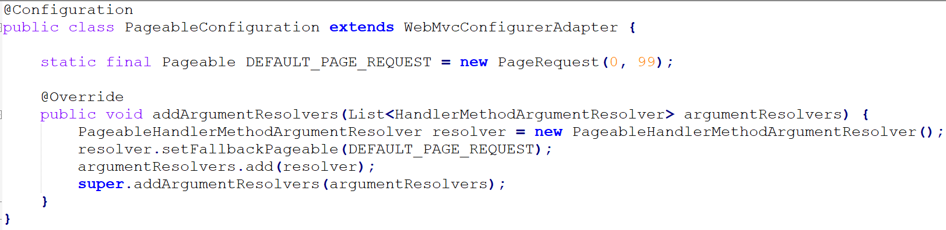

<https://github.com/jhipster/generator-jhipster/issues/6734>

* + **Cách 2**:

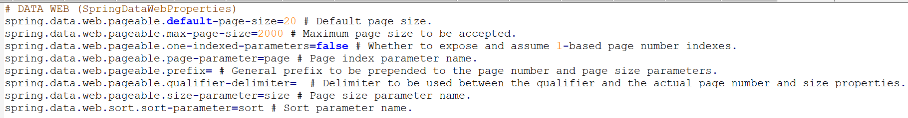

<https://stackoverflow.com/questions/39884860/how-to-configure-spring-boot-pagination-starting-from-page-1-not-0>

* **Reference**

<http://javasampleapproach.com/spring-framework/create-paging-sorting-result-spring-jpa-postgresql-spring-boot>